OLA Ride Insights
OLA Ride Analysis provides critical visibility into ride‑hailing data by uncovering patterns in trip cancellations, driver ratings, and revenue distribution. By studying these operational metrics, analysts can pinpoint recurring issues such as high‑cancellation zones, peak‑time inefficiencies, or driver behavior trends. This deeper understanding helps identify where the service is falling short and highlights opportunities to reduce customer wait times and improve overall reliability.
In addition to operational insights, the analysis also examines passenger feedback, payment preferences, and user‑reported frustrations. Understanding what annoys riders whether it is surge pricing, long pickup distances, or inconsistent driver quality allows the platform to refine its app experience and service policies. Ultimately, this research transforms raw telemetry into actionable, data‑driven strategies that not only boost company profitability but also enhance user satisfaction and long‑term customer loyalty.
For this analysis, OLA one month rides data is taken i.e., July 2024
Approach:
- Data Cleaning & Pre-processing
- SQL Query Development
- Power BI Dashboard Creation
- Streamlit Application Development & Deployment

Phase1: Data Cleaning & Pre-processing
Dataset is read using pandas. We have the following columns in the data:
Date, Time, Booking_Status, Customer_ID, Vehicle_Type, Pickup_Location, Drop_Location, V_TAT, C_TAT, Canceled_Rides_by_Customer, Canceled_Rides_by_Driver, Incomplete_Rides, Incomplete_Rides_Reason, Booking_Value, Payment_Method, Ride_Distance, Driver_Ratings, Customer_Rating, Vehicle Images.
The shape of the data is:
(103024, 20) 103024 rows, 20 columns
- Checking null values: Null value percentage for each column is

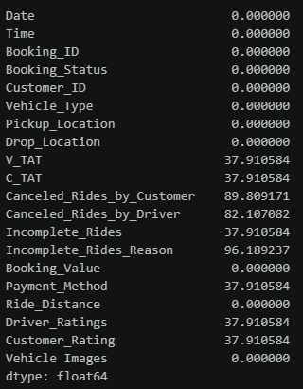
Here null values in each column are “Missing At Random (MAR)” means missing-ness of data in these columns is depended on other column; in our case it is Booking_Status column. Let’s see what we have in Booking_Status column.
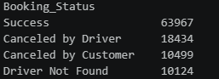
According to this we have 63,967 success records, 18,434 cancelled by driver records and so on.
So for columns V_TAT, C_TAT, Payment_Method, Incomplete_Rides, Driver_Ratings, Customer_Rating we have data where Booking_Status column is stating Success. So it is obvious because if we clearly observe those columns, those column data only exist if the booking is success. So it is normal to have null values for those columns where booking status is not success.
For imputing data in these columns we cannot go for mean, median, mode because doing such make the data wrong. So I have imputed the data as
df['V_TAT'] = df['V_TAT'].fillna(-1)
df['C_TAT'] = df['C_TAT'].fillna(-1)

V_TAT is Vehicle Turnaround Time means amount of time taken by vehicle to reach pickup location (In the data it is given in seconds) and C_TAT is Customer Turnaround Time means amount of time taken by customer to reach pickup location (In the data it is given in seconds). So imputing those columns with -1 clearly states that those are invalid (as time will not be given in negative generally) that is null replaced and it will be better than replacing with 0 because 0 may tell the people that it took 0 seconds. Note: We have to filter out -1 while doing analysis.
For Payment_Method column wherever the data is null I have imputed as ‘Not Applicable’ which is obvious.
df['Payment_Method'] = df['Payment_Method'].fillna("Not Applicable")

For Incomplete_Rides column, I have imputed null values as ‘Ride not started’ because for this column we will have data only for the rides which are started.
df['Incomplete_Rides'] = df['Incomplete_Rides'].fillna('Ride not started')

For Driver_Ratings, Customer_Rating column I imputed null values with -1(as we won’t use negative values for rating) and it is better than taking 0 because it may result as 0 rating. Note: We have to filter out -1 while doing analysis.
df['Driver_Ratings'] = df['Driver_Ratings'].fillna(-1)
df['Customer_Rating'] = df['Customer_Rating'].fillna(-1)

For column Canceled_Rides_by_Customer we have data only where Booking_Status is Canceled by Customer which is obvious because Canceled_Rides_by_Customer column is stating the reasons why customer is cancelled. Similarly for Canceled_Rides_by_Driver we have data only where Booking_Status is Canceled by Driver. So I imputed them as,
df['Canceled_Rides_by_Customer'] = df['Canceled_Rides_by_Customer'].fillna('Completed/Driver Canceled')
df['Canceled_Rides_by_Driver'] = df['Canceled_Rides_by_Driver'].fillna('Completed/Customer Canceled')

For Incomplete_Rides_Reason column we have data only where Incomplete_Rides is ‘Yes’ which is obvious because Incomplete_Rides_Reason is a reason for incomplete which only exists if a ride is incomplete. As this column is depended on Incomplete_Rides column we have to impute the data in the place of null values according to what we have in Incomplete_Rides column. So let’s see what we have in this column.
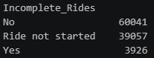
Now we have to impute separate values for ‘No’ and ‘Ride not started’.
df['Incomplete_Rides_Reason'] = np.where(df['Incomplete_Rides'] == 'No', 'Not an Incomplete Ride', df['Incomplete_Rides_Reason'])
df['Incomplete_Rides_Reason'] = np.where(df['Incomplete_Rides'] == 'Ride not started', 'Ride not started', df['Incomplete_Rides_Reason'])

By this all the missing values are resolved. Now we don’t have any null values in the data.
- Checking data types: Data type for each column is correct.
- Checking the data in each column: All the data is correct and have standard values.
We don’t have any incorrect data in our data set now. But in date column we have time along with the date, so I removed time from date column as we already have time column separately.
Now our data is ready for analysis.
To proceed further, the data frame is converted into csv file then by using mysql.connector library the data is loaded into My sql so that we can execute all our queries from python and build a streamlit web app to showcase our analysis.

Phase 2: SQL Query Development
Let’s see all the analysis one by one.
1. All Successful Bookings:
Firstly, retrieving all the rows where Booking_Status is ‘Success’. The query required for that is:
SELECT * FROM OLA_RidesData
WHERE Booking_Status = 'Success'
LIMIT 5;

As we have 63,967 success records, we will get 63,967 rows with all the columns as output which is difficult to showcase so I limited the output to 5 rows.
Now let’s understand the detailed analysis for successful bookings to understand it more clearly.
- Successful vs Unsuccessful count: The query implemented for this is
SELECT COUNT(CASE WHEN Booking_Status = 'Success' THEN 1 END) AS Successful_Bookings, COUNT(CASE WHEN Booking_Status != 'Success' THEN 1 END) AS Unsuccessful_Bookings
FROM OLA_RidesDATA;

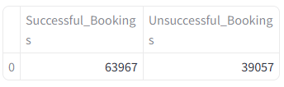
So we have 63,967 successful bookings and 39,057 unsuccessful bookings in total.
- Average V_TAT and C_TAT: The query implemented for this is
SELECT AVG(V_TAT) AS AVERAGE_V_TAT, AVG(C_TAT) AS AVERAGE_C_TAT
FROM OLA_RidesDATA
WHERE V_TAT != -1 AND C_TAT != -1;

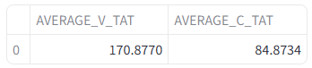
So this is the average V_TAT and C_TAT for successful bookings. That is the average time taken (in seconds) for driver and customer to reach the pickup location. Here it is less so no issues.
- Success rate for each vehicle: The query implemented for this is
SELECT Vehicle_Type, 100*COUNT(CASE WHEN Booking_Status = 'Success' THEN 1 END)/COUNT(*) AS SUCCESS_RATE
FROM OLA_RidesDATA
GROUP BY Vehicle_Type;

I show cased the output of this query as a bar chart to understand it more clearly.
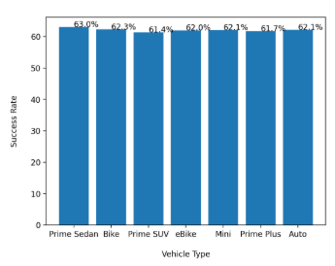
So almost each vehicle type have same success rate.
- Different payment methods usage: The query implemented for this is
SELECT Payment_Method, COUNT(*) AS USAGE_COUNT
FROM OLA_RidesDATA
WHERE Payment_Method != 'Not Applicable'
GROUP BY Payment_Method;

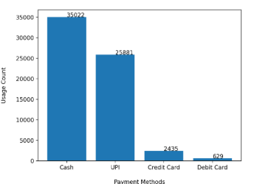
According to this, it is clear that people are mostly using cash for payment.
2. Vehicle Types:
Let’s see the average ride distance for each vehicle type. The query required for this is
SELECT Vehicle_Type, AVG(Ride_Distance) AS Average_Ride_Distance
FROM OLA_RidesData
WHERE Ride_Distance != 0
GROUP BY Vehicle_Type;

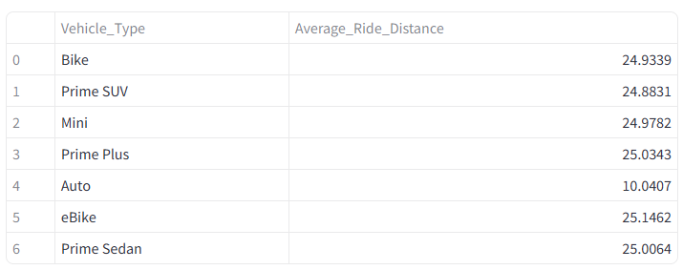
By this it is understood that vehicle types with more average distance are used for long distances and vehicle types with less average distance are used for small distance destinations. So we have to increase the availability of the vehicles (which have more average distance) in the places where people generally take long distance rides like airports or hotels and accordingly we have to increase the availability of vehicles(which have less average distance) in the places where people tend to take short rides.
- Successful vs Unsuccessful Rides for each vehicle type: The query implemented for this is
SELECT Vehicle_Type, COUNT(CASE WHEN Booking_Status = 'Success' THEN 1 END) AS SUCCESS_RIDES,
COUNT(CASE WHEN Booking_Status != 'Success' THEN 1 END) AS UNSUCCESS_RIDES
FROM OLA_RidesDATA
GROUP BY Vehicle_Type;

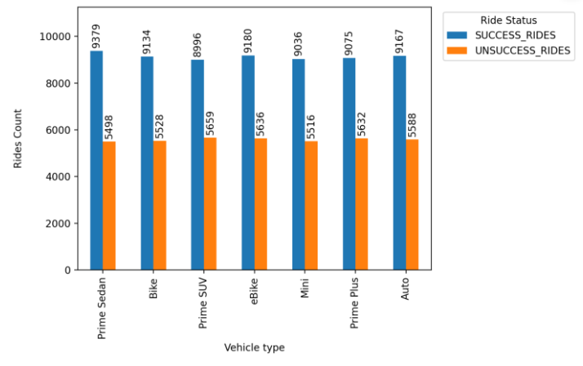
This is the successful and unsuccessful ride count for each vehicle type.
3. Cancelled Rides by Customers:
Let’s see the count and reasons for customer cancelled rides. The query that gives the count is
SELECT COUNT(*) AS Customer_Canceled_Rides
FROM OLA_RidesDATA
WHERE Booking_Status = 'Canceled by Customer

We have total of 10,499 rides which are cancelled by customers. Now coming to the reasons for this,
SELECT Canceled_Rides_by_Customer AS REASON_FOR_CANCELING, COUNT(*) AS NO_OF_TIMES_CANCELED
FROM OLA_RidesDATA
WHERE Booking_Status = 'Canceled by Customer'
GROUP BY Canceled_Rides_by_Customer;

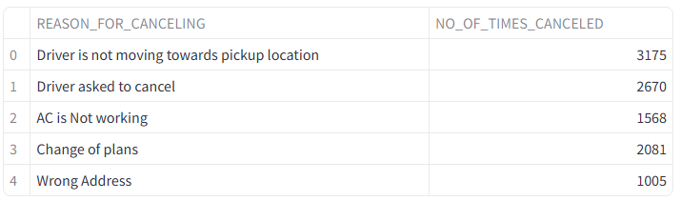
In this the last two reasons 'Change of plans' and 'Wrong address' are depended on customer, so we can't do anything for that. But the first three reasons are depended on driver and vehicle, so we have to work on those issues and resolve them to improve the business.
4. Cancelled Rides by Drivers:
Let’s see the count and reasons for driver cancelled rides. The query that gives the count is
SELECT COUNT(*) AS Driver_Canceled_Rides
FROM OLA_RidesDATA
WHERE Booking_Status = 'Canceled by Driver'

We have total of 18,434 rides which are cancelled by customers. Now coming to the reasons for this,
SELECT Canceled_Rides_by_Driver AS REASON_FOR_CANCELING, COUNT(*) AS NO_OF_TIMES_CANCELED
FROM OLA_RidesDATA
WHERE Booking_Status = 'Canceled by Driver'
GROUP BY Canceled_Rides_by_Driver;

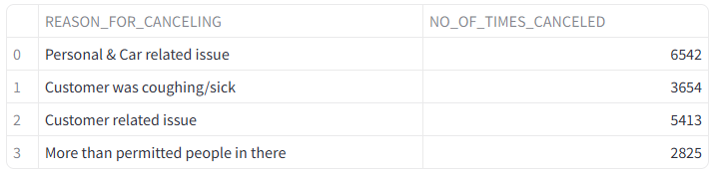
In this we have to mainly focus on 'Personal & Car related issue' and find solutions for that because it is related to driver.
5. Incomplete Rides:
Let’s see the count and reasons for incomplete rides. The query that gives the count is
SELECT COUNT(*)
FROM OLA_RidesDATA
WHERE Incomplete_Rides = 'Yes';

We have total of 3,926 incomplete rides. Now coming to the reasons for this,
SELECT Incomplete_Rides_Reason, COUNT(*) AS COUNT
FROM OLA_RidesDATA
WHERE Incomplete_Rides = 'Yes'
GROUP BY Incomplete_Rides_Reason

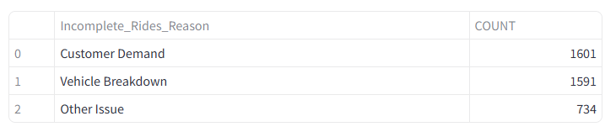
In this we have to focus more on 'Vehicle Breakdown' because it is related to the service. So we have to make sure necessary back up is in place or we should come up with any other solution to complete the journey of the customer, as these kinds of reasons will impact the service and business.
- Incomplete rides for each vehicle type: Let’s see the incomplete rides count for each vehicle type. The query required is:

SELECT Vehicle_Type, COUNT(*) AS Incomplete_Ride_Count
FROM OLA_RidesDATA
WHERE Incomplete_Rides = 'Yes'
GROUP BY Vehicle_Type
ORDER BY Incomplete_Ride_Count DESC;

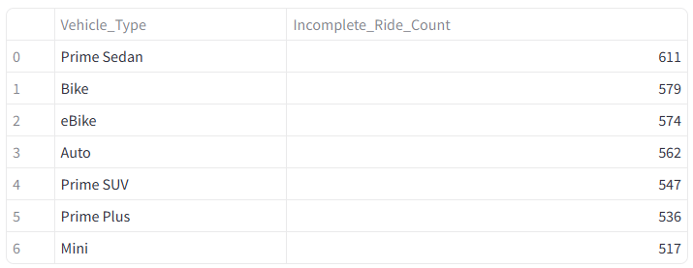
According to this 'Prime Sedan' vehicle type have more number of incomplete rides.
6. Frequent Customers:
Let’s see the top 5 customers with highest number of rides. The query implemented for this is:
SELECT Customer_ID, COUNT(*) AS No_Of_Rides
FROM OLA_RidesDATA
GROUP BY Customer_ID
ORDER BY No_Of_Rides DESC
LIMIT 5;

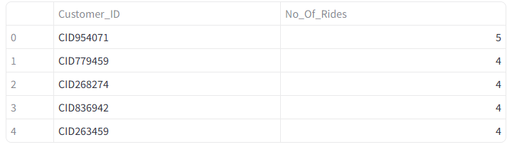
These are the top 5 customers who travelled more with OLA.
7. Driver Ratings:
Let’s see the Min, Max and Average driver ratings for each vehicle type. The query implemented for this is:
SELECT Vehicle_Type, MAX(Driver_Ratings) AS Max_Rating, MIN(Driver_Ratings) AS Min_Rating, AVG(Driver_Ratings) AS Average_Rating
FROM OLA_RidesDATA
WHERE Driver_Ratings != -1.0
GROUP BY Vehicle_Type;

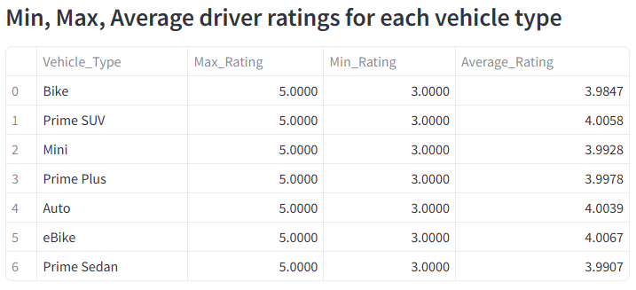
According to this each vehicle type have good and less rating.
- Rating 3 and Rating 5 count for each vehicle type: Let’s see the count of rating 3 and rating 5 for each vehicle type
Rating 3: Query implemented for this is
SELECT Vehicle_Type, COUNT(*) AS COUNT
FROM OLA_RidesDATA
WHERE Driver_Ratings = 3.0
GROUP BY Vehicle_Type
ORDER BY COUNT DESC;

Rating 5: Query implemented for this is
SELECT Vehicle_Type, COUNT(*) AS COUNT
FROM OLA_RidesDATA
WHERE Driver_Ratings = 5.0
GROUP BY Vehicle_Type
ORDER BY COUNT DESC;

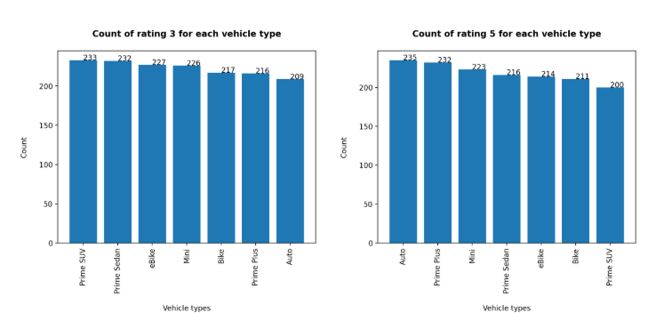
Now it is clearly understandable which vehicle type have more number of Rating 3 and Rating 5. According to this we can implement solutions and improve the ratings.
8. Customer Ratings:
Let’s see the Average customer ratings for each vehicle type. The query implemented for this is:
SELECT Vehicle_Type, AVG(Customer_Rating) AS Average_Rating
FROM OLA_RidesDATA
WHERE Customer_Rating != -1.0
GROUP BY Vehicle_Type;

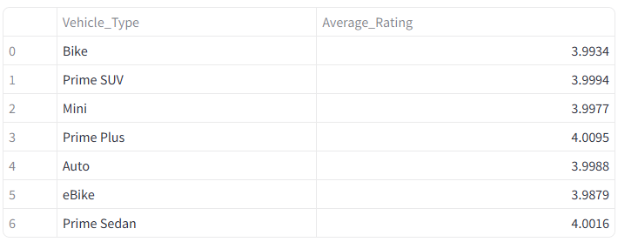
This is the average customer rating (Rating given by driver to customer) for each vehicle type. We have almost same average ratings for each vehicle type.
9. Payment Methods:
As we already saw the different payment methods usage, let’s now see the revenue made through each payment method. The query required for this is:
SELECT Payment_Method, SUM(Booking_Value) AS REVENUE_MADE
FROM OLA_RidesDATA
WHERE Payment_Method != 'Not Applicable'
GROUP BY Payment_Method;

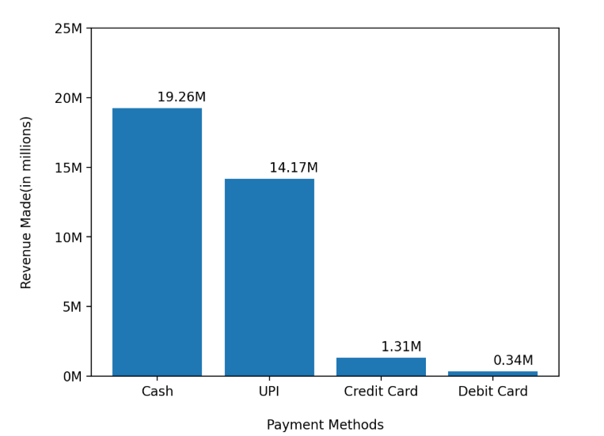
As cash is the most used payment method, more revenue is made through cash payment.
10. Revenue:
Let’s see the total booking value of rides completed successfully. The query is:
SELECT SUM(Booking_Value) AS Total_Booking_Value
FROM OLA_RidesDATA
WHERE Incomplete_Rides = 'No';
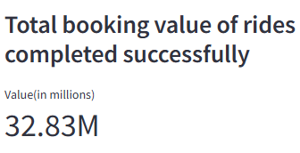
Let’s see the total booking value of rides incomplete. The query required is:
SELECT SUM(Booking_Value) AS Total_Booking_Value
FROM OLA_RidesDATA
WHERE Incomplete_Rides = 'Yes';
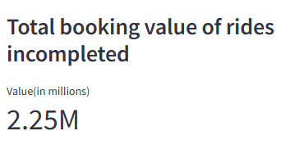
Let’s see the total booking value of cancelled rides. The query required is:
SELECT SUM(Booking_Value) AS Total_Booking_Value
FROM OLA_RidesDATA
WHERE Booking_Status != 'Success';

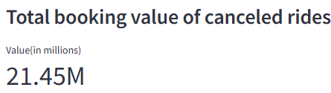
Let’s segregate this and see the total booking value for each type of cancelation.
- Total booking value of driver cancelled rides. The query required is:
SELECT SUM(Booking_Value) AS Total_Booking_Value
FROM OLA_RidesDATA
WHERE Booking_Status = 'Canceled by Driver';
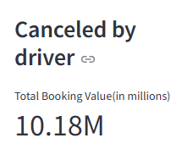

- Total booking value of customer cancelled rides. The query required is:
SELECT SUM(Booking_Value) AS Total_Booking_Value
FROM OLA_RidesDATA
WHERE Booking_Status = 'Canceled by Customer';
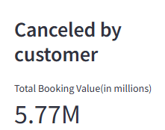

- Total booking value of ‘Driver Not Found’ rides. The query required is:
SELECT SUM(Booking_Value) AS Total_Booking_Value
FROM OLA_RidesDATA
WHERE Booking_Status = 'Driver Not Found';

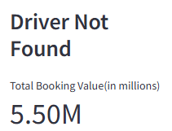

Phase 3: Power Bi Dashboard Creation

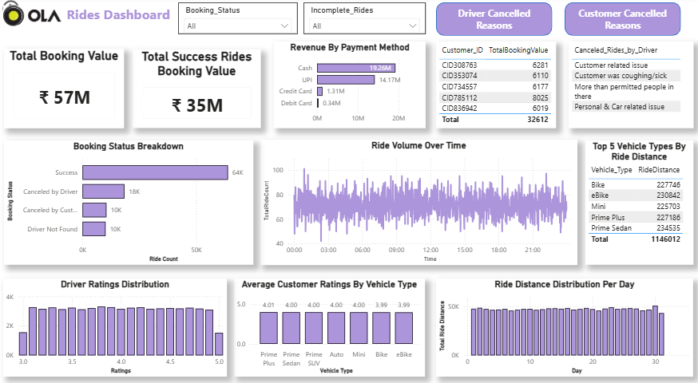
This is the dashboard created using power bi where all the important analysis was shown.
Let’s understand this by navigating through each one from top left.
On the top I have given OLA logo then name then I have given two slicers
Slicer 1: It has the unique values of Booking_Status column which by selecting will impact the ‘Total Booking Value’ card value.
Slicer 2: It has the unique values of Incomplete_Rides column i.e., ‘Yes’ and ‘No’ which by selecting will impact the ‘Total Success Rides Booking Value’ card value, ‘Booking Status Breakdown’ chart, ‘Revenue By Payment Method’ chart.
After the slicers, I have given two buttons because I have bookmarks in my dashboard and for that these buttons are used.
Coming to the next line, first one is a card which has ‘Total Booking Value’ (it includes success and unsuccessful rides values), second one is also a card which has ‘Total Success Rides Booking Value’. Then we have ‘Revenue By Payment Method’ chart where revenue made through each payment method was given. After that I have given a table which has top 5 customers by total booking value. Then comes another table which has ‘Cancelled rides by driver reasons’ and I created bookmark for this because there is one more table hiding behind this table which has ‘Cancelled rides by customer reasons’ and I created bookmark for this too. So when the button ‘Driver Cancelled Reasons’ (which is there on the top) is clicked we can see ‘Cancelled rides by driver reasons’ and when the button ‘Customer Cancelled Reasons’ is clicked we can see ‘Cancelled rides by customer reasons’.
Coming to the next line, I have given ‘Booking Status Breakdown’ that is the count of each status, then we have ‘Ride Volume over Time’ that is the number of rides booked in each minute. After that we have a table which has ‘Top 5 vehicle types by ride distance’ that is the top 5 vehicle types with highest ride distance.
Coming to the last line, I have given ‘Driver Ratings Distribution’ that is the number of times each rating was given. Then we have ‘Average customer rating per vehicle type’. At last I have given ‘Ride distance distribution per day’ that is the total ride distance covered in each day.

Phase 4: Streamlit Application Development & Deployment
After completing the analysis an interactive streamlit web application is built using streamlit library to showcase all the results. Then it is deployed in Render cloud platform.
This is the URL for web application: https://ola-ride-insights-ziix.onrender.com

